To use the system that we have developed outside of the development environment it is necessary to deploy it in an environment prepared to simulate the final system that will support that system when it is ready.
To perform the deployment, we need the two virtual machines that we have, the development and the pre-production. The first one we will use to export the project to a packaged file and the second for that file to load the system.

Development enviroment

In our development environment we will have to export the project as a .war package, which will later be the one that deploy in the pre-production environment.
For this we will right click on Acme-Immigrant and in the dropdown menu select "Export", and there to "WAR file". Once selected the file type choose where we export, the name and confirm that we want to optimize for the Apache Tomcat version 7, which we use in both environments.
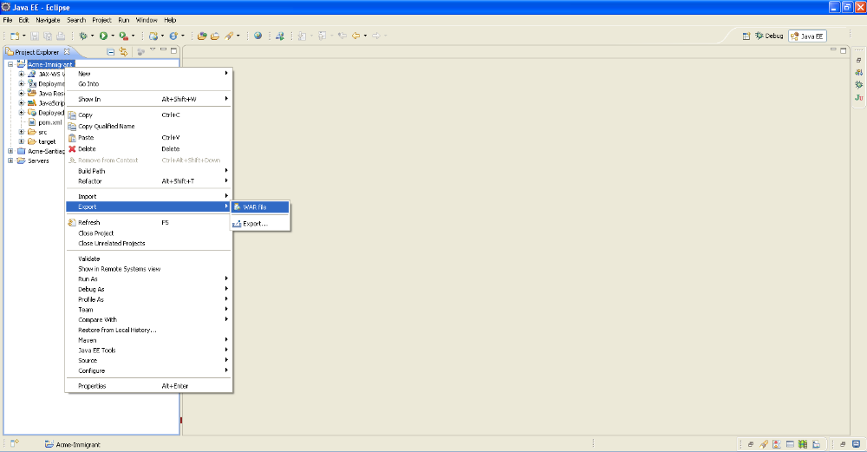

We must also export our database to create it later in the pre-production environment. To do this we will open a console, by pressing the Windows key and the R key and entering in the window that shows "cmd". Once you open the Windows console, navigate through the directories with the command "cd" to position in the path "C:\Program Files\MySQL\MySQL Server 5.5 \bin". Located on that route we will write "mysql -u root -p Acme-immigrant > script-immigrant.sql", being Acme-immigrant the database that we want to export, and script-immigrant.sql the file to which we want to dump the information. After giving enter will ask for the password of MySQL administrator and after entering and return to give to enter is created in that path the file .sql.
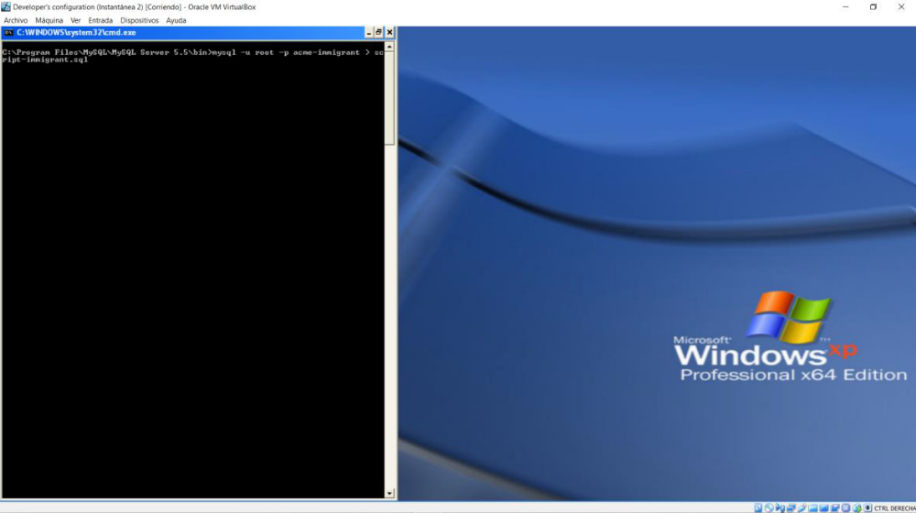

This file before using it in the pre-production machine is necessary to clean it of unnecessary data and to introduce certain introductions so that the database is created correctly. The data that we must delete are all those that contain the tables except those strictly necessary for the correct functioning of the system, like the account of the principal administrator, and in this case the root category to be able to add the remainder.
On the other hand those that we have to introduce are the instructions with which we will create the users that uses our system, “acme-user” and “acme-manager”, we give permissions on the database and also indicate to the database that the script should run in a single transaction, so if there is any error in the creation the changes are undone.

Also, for debugging reasons we create a drop .sql file where you delete the users, as well as their permissions and finally the database.
With these three files we are ready to deploy in the pre-production environment.

Pre-production enviroment

First we copied both files .sql in the path "C:\Program Files\MySQL\MySQL Server 5.5 \bin" and open the Windows console as in the development environment, but this time the command to run is "mysql -u root -p < script-immigrant.sql", to create the database in this environment.
If it has been created successfully now is the turn to deploy the .war file, we start the Tomcat service in case of not being on, open the Internet browser and in the address bar write "localhost/manager" to access the panel Apache Tomcat Administration. There in the section "deploy" we introduce as context "\" and enter the path of the .war file, then we give to deploy.
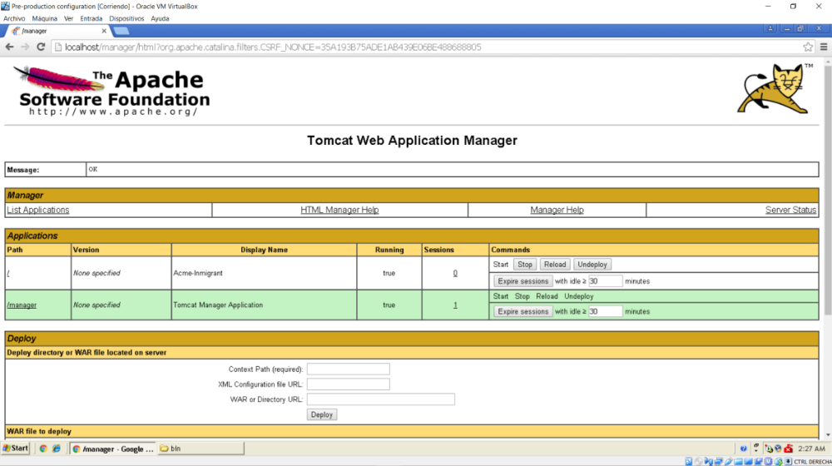
Finally, we must edit the hosts file of our system so that when you put in the address bar "www.acme.com" We redirected to "localhost", where our application is deployed. To do this using the open command console as administrator, we go to the path "C:\Windows\System32\drivers\etc" and write "notepad hosts" to open that file with the editor of notes. In that file we must write an entry where we say that when we write the address specified before we redirected to localhost, we got it by typing "127.0.0.1 www.acme.com”.
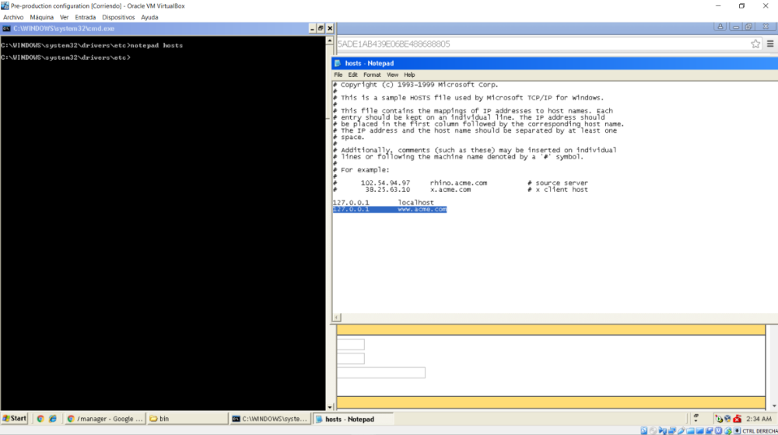
When you save it will redirect us correctly to our application, which will have it deployed and ready to work.

